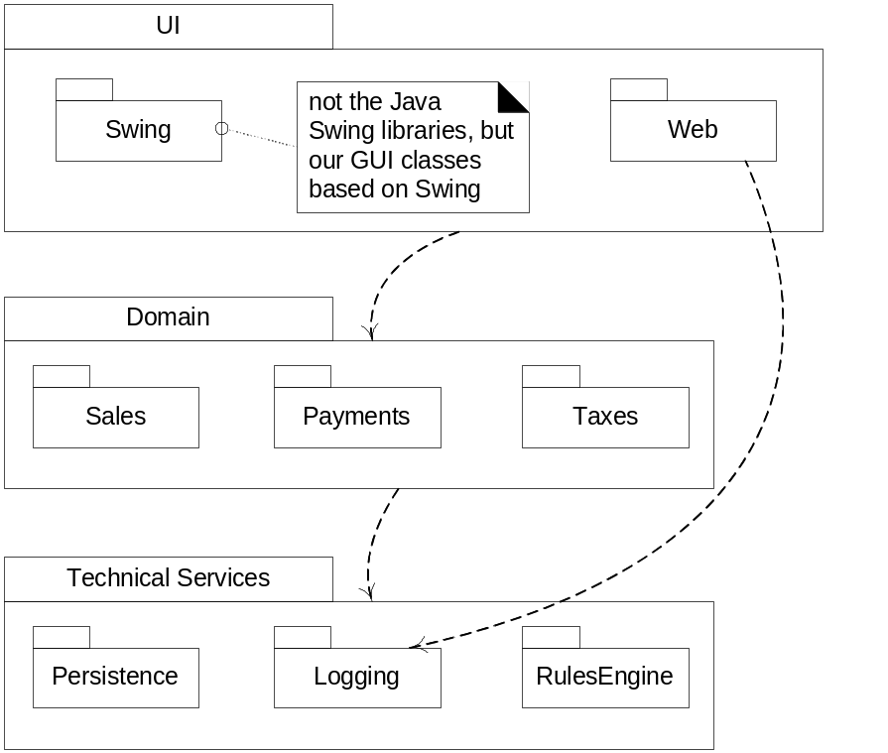

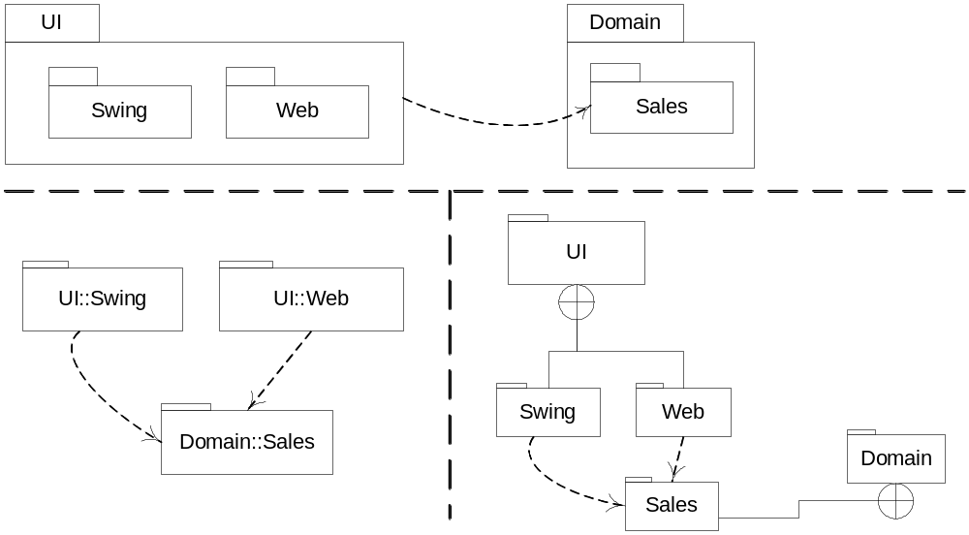

Layer: a very coarse-grained grouping of classes, packages, or subsystems that has cohesive responsibility for a major aspect of the system.
Layered Architectures
- Typical layers in an OO system:
  - User Interface
  - Application Logic and Domain Objects
  - Technical Services
    - Application-independent, reusable across systems.
- Relationships between layers:
  - Strict layered architecture: a layer only calls upon services of the layer directly below it.
  - Relaxed layered architecture: a higher layer calls upon several lower layers.

Design with Layers
- Organize the large-scale logical structure of a system into discrete layers of distinct, related responsibilities.
  - Cohesive separation of concerns.
  - Lower layers are general services.
  - Higher layers are more application-specific.
- Collaboration and coupling is from higher to lower layers.
  - Lower-to-higher layer coupling is avoided.
Benefits of a Layered Architecture
- Separation of concerns:
E.g., UI objects should not do application logic (a window object should not calculate taxes) nor should a domain layer object create windows or capture mouse events.
  - Reduced coupling and dependencies.
  - Improved cohesion.
  - Increased potential for reuse.
  - Increased clarity.
- Related complexity is encapsulated and decomposable.
- Some layers can be replaced with new implementations.
- Lower layers contain reusable functions.
- Some layers can be distributed.
  - Especially Domain and Technical Services.
- Development by teams is aided by logical segmentation.

